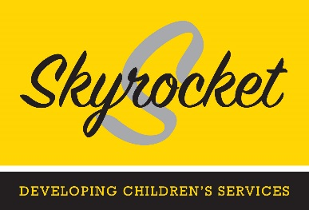
Please complete this booking form in full using BLOCK capitals and either post to Administration at Hanbury Court, Harris Business Park, Stoke Prior, B60 4DJ or email to info@skyrocket.org.uk

1. Course Details

Course | Date

2. Pricing

 | Price | x | Office Use only (Discount applicable)
Charity/Not for Profit  Local Authority  IFA | £300  £300  £375

3. Candidate Details

Name and Job Title | Email | Telephone

4. Organisation Details for Invoice

Name of Organisation | Invoice Address Details and email address | Purchase Order

5. Additional Requirements

Do you have any specific cultural and/or dietary needs

6. Experience

Please give a brief overview of you experience.

Signed _____________________________________ Date ________

Booking Terms and Conditions

- You may substitute one candidate for another at no charge, but please complete an additional booking form and return it.
- For bookings a 50% refund of the full amount will be given for cancellations made no later than 14 days prior to the training date. No refunds will be given for cancellations made within 14 days of the training date.
- All cancellations must be confirmed in writing.
- We reserve the right to change or cancel course dates at our discretion to meet resources availability and customer requirements without any liability to ourselves.
- All candidates are required to comply with the Health and Safety guidelines for the venues they are attending.

Data Protection

We will use your information for administering your attendance at Skyrocket training courses and to keep you informed of future Skyrocket events. If you do not want us to do this please let us know. We do not share your details with any organisation outside of Skyrocket Partnerships Limited. A full privacy policy is available on our website.

